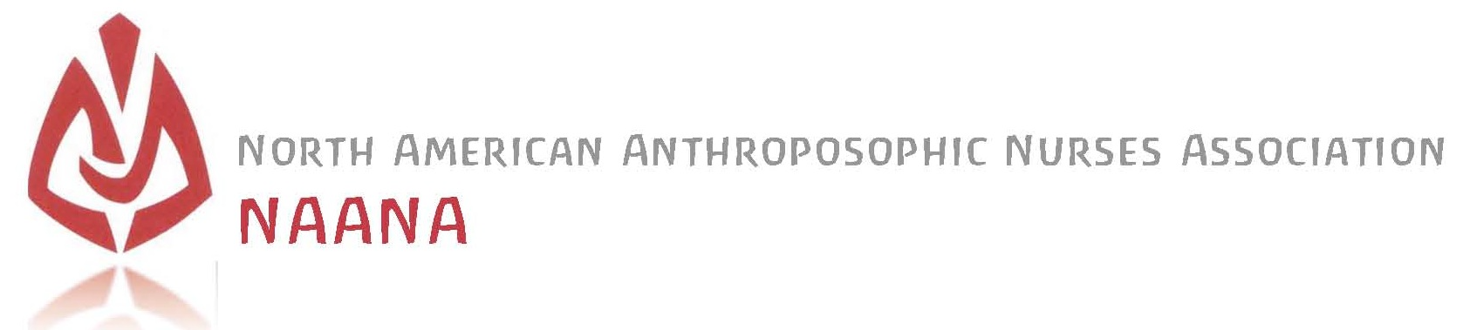
Foundation Course in Anthroposophic Nursing
Anthroposophic Homecare Course
* * *
Glenmoore, Pennsylvania
Tuition is $900. for each 6 day module
Early registration discount of $75. for module 1 is February 1, 2022
NAANA membership discount of $75. will be applied for members
For Information about this training contact:
naanatraining@gmail.com * info@rhythmicalmassagetherapynorthamerica.org
North American Anthroposophic Nurses Association
(NAANA) * anthroposophicnursing.org
AN FC  Homecare Course  RMT Training | For  Registered Nurses,  Health Care Professionals  & Caregivers | Module 1 – 6 days Monday July 25 - Saturday July 30, 2022  Module 2 – 6 days  Spring 2023  Module 3 – 6 days Summer 2023  Module 4 – 6 days Spring 2024 | Karen Alderfer, RN, BSN, ANS, RES  Janice Balaskas, RN, ANS, RES, RMT
Rhythmical Massage Therapy Association of North America
(RMTA of NA) * rhythmicalmassagetherapynorthamerica.org
RMT Training | For  Health Care Professionals | Module 5 Spring 2024  6 days training  Module 6 Summer 2024  12 days training  Module 7 Spring 2025  12 days training  Module 8 Summer 2025  12 days training  Module 9 Spring 2026  12 days training  Module 10 Summer 2026  12 days training | Janice Balaskas, RN, ANS, RES, RMT  Marei Blitz,  PT, RMT  Aoine Landweer-Cooke, MT, RMT
The Foundation Course in Anthroposophic Nursing is given in four six-day modules over two years in Glenmoore, Pennsylvania. The training will address the fundamental principles of Anthroposophy, extending particularly to the Anthroposophic view of the human being in health and illness and support of processes of care and healing. This course provides an introduction to the three-fold, four-fold, seven-fold and twelve-fold dynamic relationships of the human being, and of their practical application in nursing care and therapeutic support. Equally important to the practical applications is the path of inner development of the nurse, therapist and caregiver that elevates how we think, feel and enact our work to its highest potential. This aspect will accompany all of the practical work.
The training includes:
1) External Applications of compresses & poultices.
2) Therapeutic baths such as footbaths, sounding washing & oil dispersion baths.
3) Rhythmical Einreibungen according to Wegman/Hauschka – a gentle application of therapeutic oils working with the flow of body forms & processes to support health & well-being.
4) The Anthroposophic Nursing Process as a path of inner development of the nurse, therapist & caregiver.
This Foundation Course in Anthroposophic Nursing is open to all interested individuals to enroll. At the completion of each module, Registered Nurses receive a Certificate of Attendance in NAANA’s Foundation Course in Anthroposophic Nursing. Other Health Care Professionals and Caregivers receive a Certificate of Attendance in NAANA’s Anthroposophic Homecare Course.
This Foundation Course in Anthroposophic Nursing will apply for accreditation by the International Forum for Anthroposophic Nursing (IFAN) in the Medical Section of the School of Spiritual Science at the Goetheanum in Dornach, Switzerland. IFAN represents national professional Anthroposophic Nursing associations worldwide and serves to support and acknowledge training programs in Anthroposophic Nursing. It guarantees the equivalence of training and further training programs of all institutions that are closely connected to the International Forum for Anthroposophic Nursing in the Medical Section at the Goetheanum, see anthronursing.care.
* * *
Certification as an Anthroposophic Nurse requires:
- Current license as a Registered Nurse.
- Full attendance at the Foundation Course in Anthroposophic Nursing for two years.
  - Minimum in-class learning time = 200 Learning Units
  - Minimum independent self-study = 135 hours which includes
    - 80 hours of mentored practical learning activities, including related theory & reflection
    - 35 hours of self-study & project work
- Completion of all course assignments including
- Within the 80 hours of practical learning activities complete:
- 30 Care Reports for Rhythmical Einreibungen representing experience with patients of various ages, health conditions and health needs, as well as various types of treatment.
- 15 Care Reports for External Application representing experience with patients of various ages, health conditions and health needs, as well as various types of treatment.
- 1 day observation in an anthroposophic health care facility, such as a doctor’s office, clinic, anthroposophic hospital or with a school nurse or anthroposophic therapist at a Waldorf School or Camphill Community
- Mentoring Meetings with documentation
- Learning Journal – a personal reflective journal of process and learning throughout the years including questions and insights
- Job Shadowing or Internship (optional)
  - Within the 35 hours of self-study & project work:
- 1 Plant Study including Goethean Observation and drawing or artistic rendering of plant – required
- Final Paper on topic related to Anthroposophic Nursing – 3 pages or group project on an AN topic – required
- Observation Exercises or additional plant studies – optional
- Group Work – self-study in person or online ideas include reading a chapter in the textbook or other book and discuss meeting monthly or as desired – optional
- Artistic Work – artistic representations related to the course content. i.e. drawing of plants, the RE movements, or specific muscles, writing a poem, etc. – optional
- Total independent self-study time averages 1.5 hours a week the over the course of 2 years – with variations & flexibility for the individual student
- Mentoring with an Anthroposophic Nurse for the two years of the Foundation Course is included in the training. This is intended to support the nurse and non-nurse in self-study learning between modules. See NAANA’s Mentoring Program on this website.
- Demonstration of a satisfactory level of knowledge and practical skills during the Foundation Course.
- Recommendation by the Mentor.

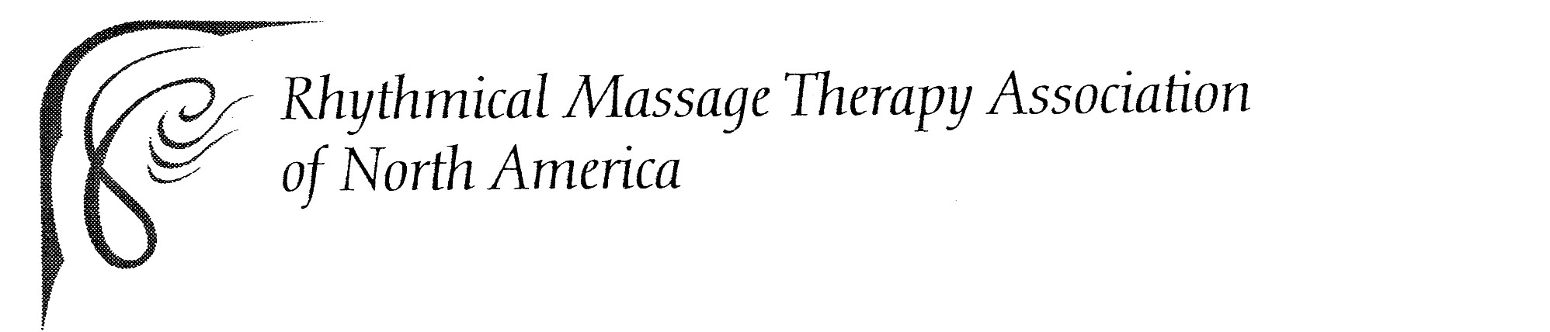
Rhythmical Massage Therapy Training
The Camphill School, 1784 Fairview Road, Glenmoore, Pennsylvania
Tuition To Be Determined
For Information about this integrated training contact:
info@rhythmicalmassagetherapynorthamerica.org
Rhythmical Massage Therapy Association of North America
(RMTA of NA) * rhythmicalmassagetherapynorthamerica.org
For  Health Care Professionals | Module 5 Spring 2024  6 days training  Module 6 Summer 2024  12 days training  Module 7 Spring 2025  12 days training  Module 8 Summer 2025  12 days training  Module 9 Spring 2026  12 days training  Module 10 Summer 2026  12 days training | Janice Balaskas,  RN, ANS, RES, RMT  Marei Blitz, PT, RMT  Aoine Landweer-Cooke,  MT, RMT
Upon completion of the four-module Foundation Course in Anthroposophic Nursing offered by NAANA, health care professionals have the option to continue training in Rhythmical Massage Therapy through the Rhythmical Massage Therapy Association of North America (RMTA of NA). The prerequisite for the Rhythmical Massage Therapy Training is the completion of 500 hours in an accredited therapeutic massage training, or licensure in a healthcare profession such as nursing, physiotherapy, medicine or other body oriented health care modality. Students currently pursuing certification in one of the above pre-requisites are welcome to inquire.

Rhythmical Massage Therapy as indicated by Dr. Ita Wegman,
is a therapeutic massage based on the teaching of Ita Wegman, MD and Margaretha Hauschka, MD, and Rudolf Steiner, Ph.D. Through their collaboration, the conventional methods of therapeutic massage were extended to include the spiritual-scientific processes of study of the human being and the world, collectively known as anthroposophy. This anthroposophic approach to massage encompasses multiple perspectives that address the human being as a being of body, soul, and spirit.
The four-week Foundation Course in Anthroposophic Nursing will serve as weeks 1 – 4 of an 18-week Rhythmical Massage Therapy training. The course content will follow guidelines for training as outlined by the International Forum for Rhythmical Massage Therapy (IFRMT) in the Manual for Accreditation for Basic, Further and Advanced Training Courses in Rhythmical Massage Therapy as indicated by Dr. Ita Wegman. See the table below for an overview of the training content. The course will seek accreditation with the IFRMT. For more information about the Rhythmical Massage Therapy Association of North America and this integrated training, see the website rhythmicalmassagetherapynorthamerica.org.
The RMTA of NA is a member of the Anthroposophic Health Association (AHA), the interdisciplinary association for anthroposophic therapies in North America, anthroposophichealth.org, and the International Forum for Rhythmical Massage Therapy (IFRMT). The IFRMT is a member of the International Medical Section at the Goetheanum, Dornach, Switzerland.

Rhythmical Massage Therapy * Training Overview
Anthroposophic Health Care:  - Embryology  - Four-Fold Studies:  Elements, Ethers, Kingdoms of Nature, Four-Fold Human Being  - Three-Fold Studies:  Three-Fold Plant, Tria Principia, Functional Systems of the Human Being (Nerve-Sense System, Rhythmic System, Metabolic-Limb System), Soul Forces (Thinking, Feeling, Willing)  - Seven-Fold Studies:  - Life Processes,  Learning Processes, Planets,  Organ Systems, Metals  - Twelve Fold Studies:  Senses, World Views, Constellations  - Polarities in Health & Illness:  Anabolism & Catabolism, Inflammation & Sclerosis | Observation:  - Phenomenological Observations  - Tactile Explorations  - Goethean Observation  Intervention:  - Developing Illness Pictures  - Developing Treatment Plans  - Therapeutic Plants & Substances  - Working in a Multi-Disciplinary Team  Inner Development:  - Exercises in Inner Development  - Art & Eurythmy  Self-Study Assignment:  - To Be Determined
Practical Learning:  - Effleurage/Gliding & Variations  - Petrissage/Kneading & Variations  - Counter-Circles & Variations  - Warming Circles & Variations  - Lemniscates & Variations  - Frictions  - Pine Tree  - Organ Treatments: Liver, Spleen, Heart, Kidney, Bladder  - Rhythmical Einreibungen  - Pentagram Treatment | Treatment Sequences:  - The Face  - Basic Back  - Neck Diversion  - Asthma  - Arms Up  - Arms Down  - The Hand  - Sciatica  - Abdomen  - The Hip  - The Knee  - Legs Prone  - Legs Supine  - Calves Breathing & Calves Down  - The Foot

